TU 257 – Fundamentals of Data Science

Data Analytics

L4 – Classification – Part 1

Brendan Tierney

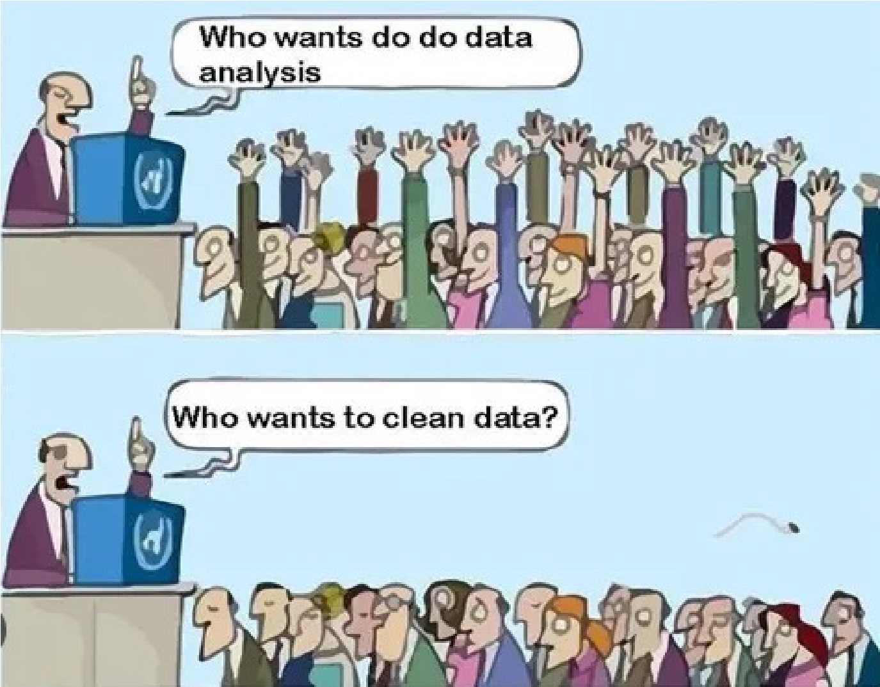

Data

Data

Analysts

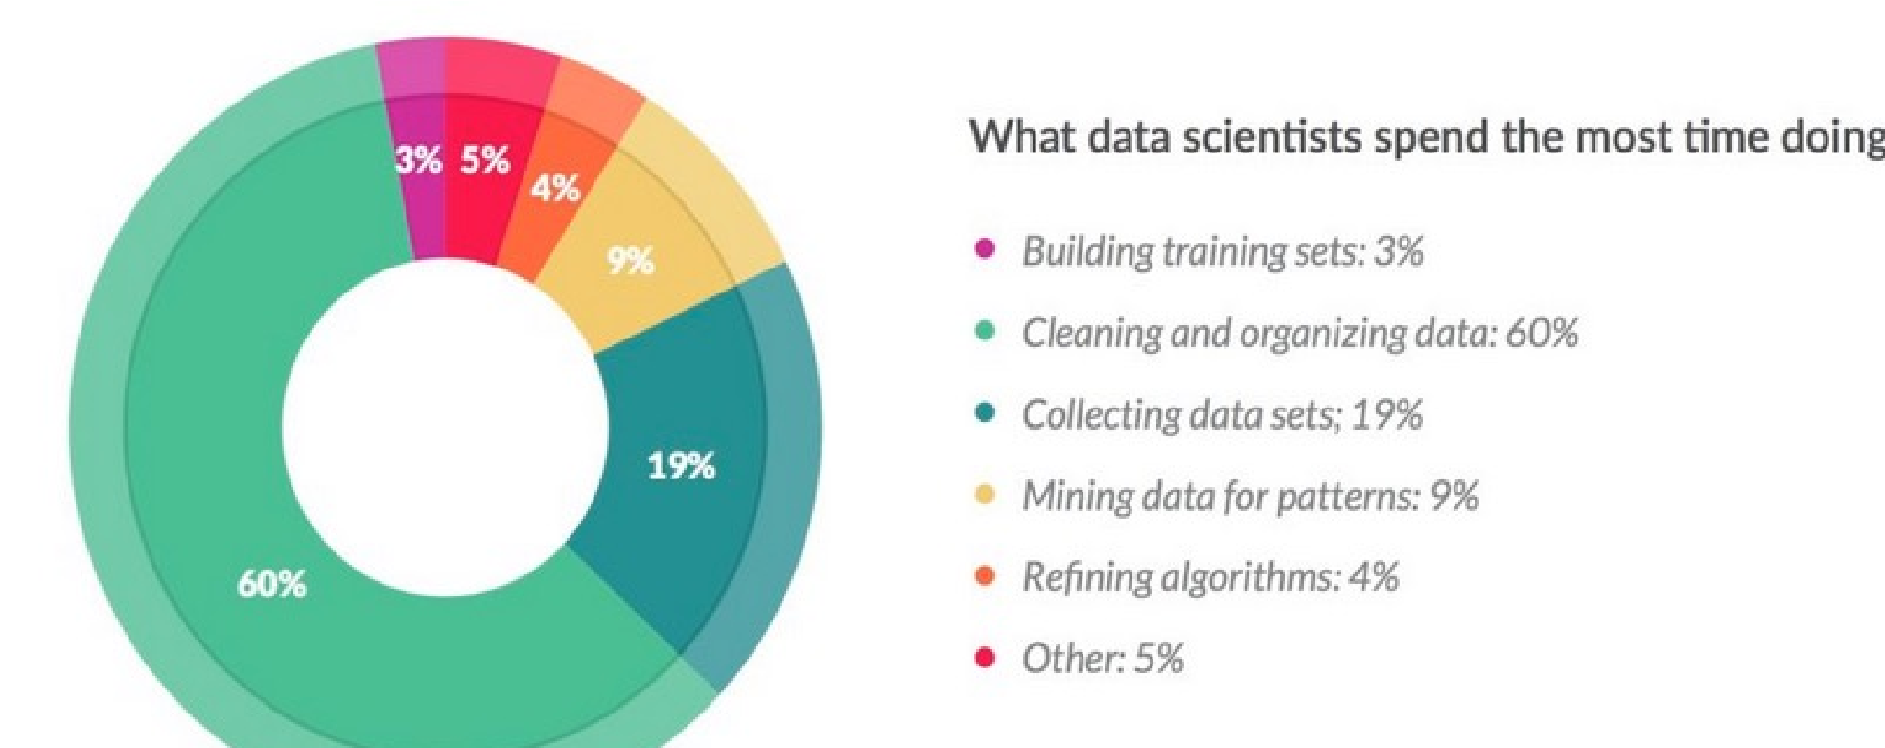

Agenda

•

What is Classification

•

What type of problems

•

The Typical Process

•

Preparing Data

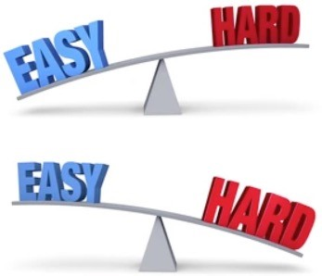

* Lots of Algorithms
* Subset this week
* More next week
* Not all will be covered
* Some details/background/under-the-hood at the algorithms
* Inner details are not needed. Can be explored in a Machine Learning module
* How do you measure if it’s any good

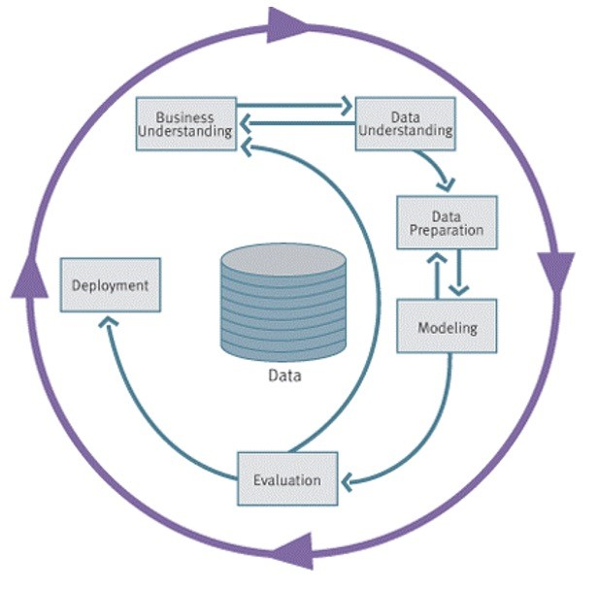

**4**

# Data Mining / Machine Learning

• the use and development of computer systems that are able to learn and adapt without following explicit instructions, by using algorithms and statistical models to analyse and draw inferences from patterns in data.

Data Mining / Machine Learning

Classification

Regression

Clustering

Supervised MLUnSupervised ML

Association Rules Naïve Bayes

Logistic RegressionGradient BoostingDecision Trees Hierarchical ClusteringDBSCAN ClusteringKmeans FpApriori-growth

Random Forest

Support Vector Machine

K-nearest neighbors

Neural Networks

Regression AutoML

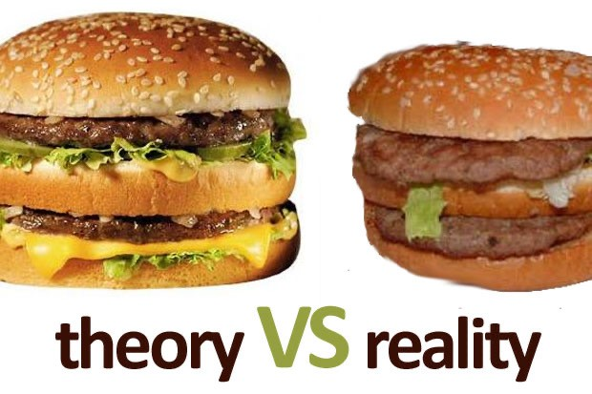

* Most Data Analytics etc can be done in a few lines of code
* Don’t worry about the Theory, we might touch upon some of it, but it isn’t necessary to know in-depth
* You’ll never have to write an algorithm from scratch

# What is Classification

* Classification is a task that requires the use of (machine learning) algorithms that learn how to assign a class label to examples from the problem domain.
* We learn from the past to predict the future
* 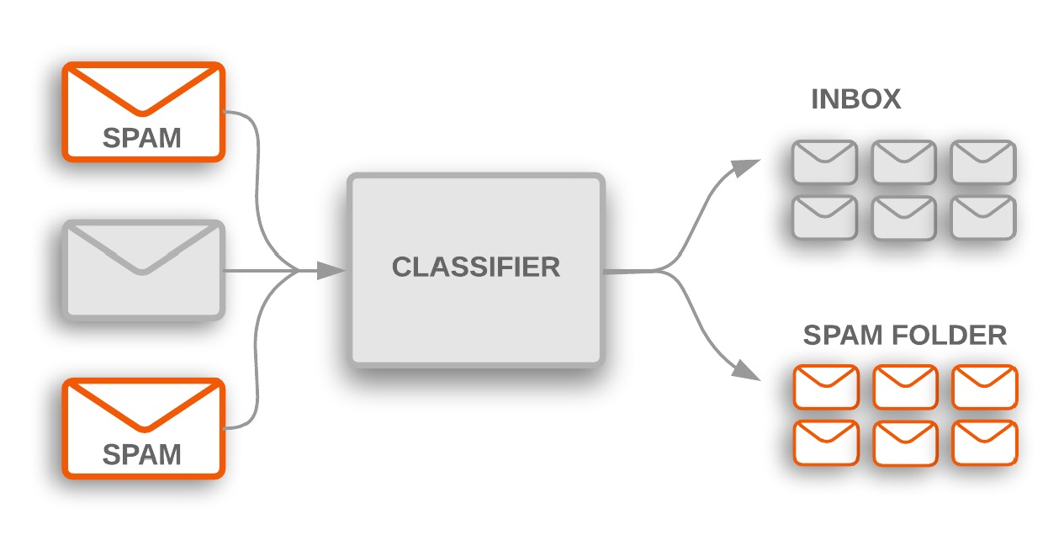An easy to understand example is classifying emails as “*spam*” or “*not spam*.”
* Classification predictive modeling involves:
* Looking at historical data representing a particular scenario
* Using algorithms to find patterns in the data
* What attributes/features contribute towards determining the scenario being investigated
* Assign a class label.

# Classification – Different types

* 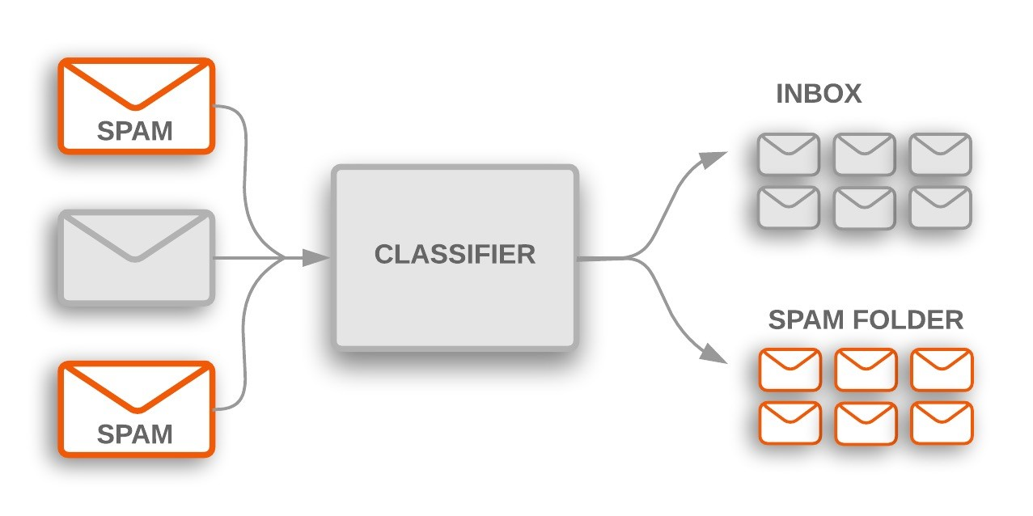Binary classification refers to predicting one of two classes
* Yes / No
* 0 / 1
* Buy / Not-Buy
* Spam / Not-Spam
* 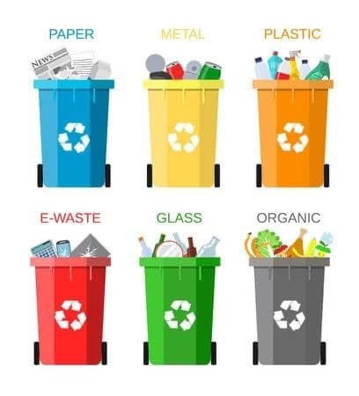Multi-class Classification is when we have more than two class values
* Different Fruits
* Credit Ratings
* Different Products

# Classification: Definition

* Given a collection of records (*training set* )
* Each record contains a set of *attributes*, one of the attributes is the *class*.
* Find a *model* for the class attribute as a function of the values of other attributes.
* Goal: previously unseen records should be assigned a class as accurately as possible.
* A *test set* is used to determine the accuracy of the model. Usually, the given data set is divided into training and test sets, with training set used to build the model and test set used to validate it.

# Classification—A Two-Step Process

* Step 1 - Model Construction: describing a set of predetermined classes
* Each tuple/sample is assumed to belong to a predefined class, as determined by the class label attribute
* Create a sub-set of tuples to be used for model construction: training dataset
* Create a models using different algorithms
* Each algorithms takes the training dataset as input

• Step 2 – Model Test & Evaluation

* The model is represented as classification rules, decision trees, or mathematical formulae
* Estimate accuracy of the model
* The known label of test sample is compared with the classified result from the model
* Accuracy rate is the percentage of test set samples that are correctly classified by the model
* Test set is independent of training set, otherwise over-fitting will occur

# Classification—A Two-Step Process or is it a Three Steps

* Step 1 - Model Construction: describing a set of predetermined classes
* Each tuple/sample is assumed to belong to a predefined class, as determined by the class label attribute
* Create a sub-set of tuples to be used for model construction: training dataset
* Create a models using different algorithms
* Each algorithms takes the training dataset as input

• Step 2 – Model Test & Evaluation

* The model is represented as classification rules, decision trees, or mathematical formulae
* Estimate accuracy of the model
* The known label of test sample is compared with the classified result from the model
* Accuracy rate is the percentage of test set samples that are correctly classified by the model
* Test set is independent of training set, otherwise over-fitting will occur
* Step 3 – Using the Model on new data
* Put into production
* Use on newly generated data
* Need to constantly Review and assess if the model needs to be update § Iterative

be “scored” for predictions

Transactional

Data

Historical data



Assembled &

Integrated data

Data

Integration

Predictions &

Insights

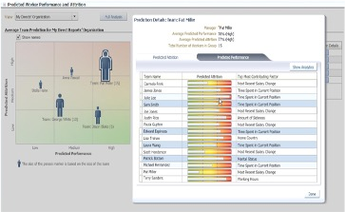

Make Prediction



Additional relevant

data and

“engineered

features”



Historical or Current Data to



Build Predictive

Model

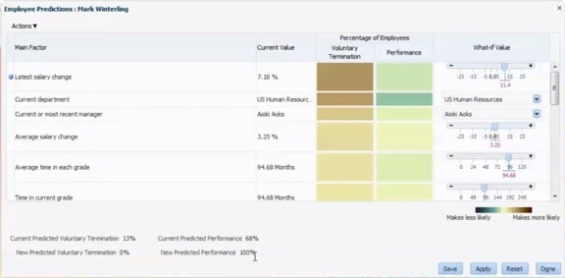

Data Engineering

Transactional

Data

Historical data



Assembled &

Integrated data

Data

Integration

Predictions &

Insights



Make Prediction



Additional relevant

data and

“engineered

features”



Historical or Current Data to

be “scored” for predictions



Build Predictive

Model



Model Training

Data Engineering & Evaluation

Transactional

Data

Historical data



Assembled &

Integrated data

Data

Integration

Predictions &

Insights

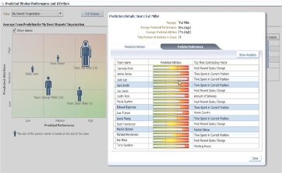

Make Prediction



Additional relevant

data and

“engineered

features”



Historical or Current Data to

be “scored” for predictions



Build Predictive

Model



Model Training

Transactional

Data

Historical data



Assembled &

Integrated data

Data

Integration

Predictions &

Insights



Make Prediction



Additional relevant

data and

“engineered

features”



Historical or Current Data to

be “scored” for predictions



Build Predictive

Model



Data Engineering

& Evaluation

Model Deployed in Production /

MLOps

# Data Set = Training + Test sata sets

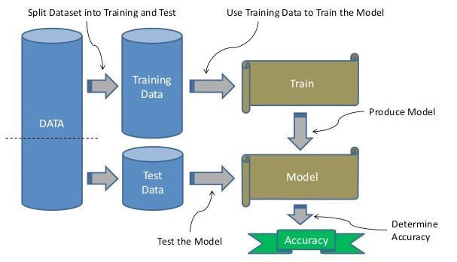

The Algorithms

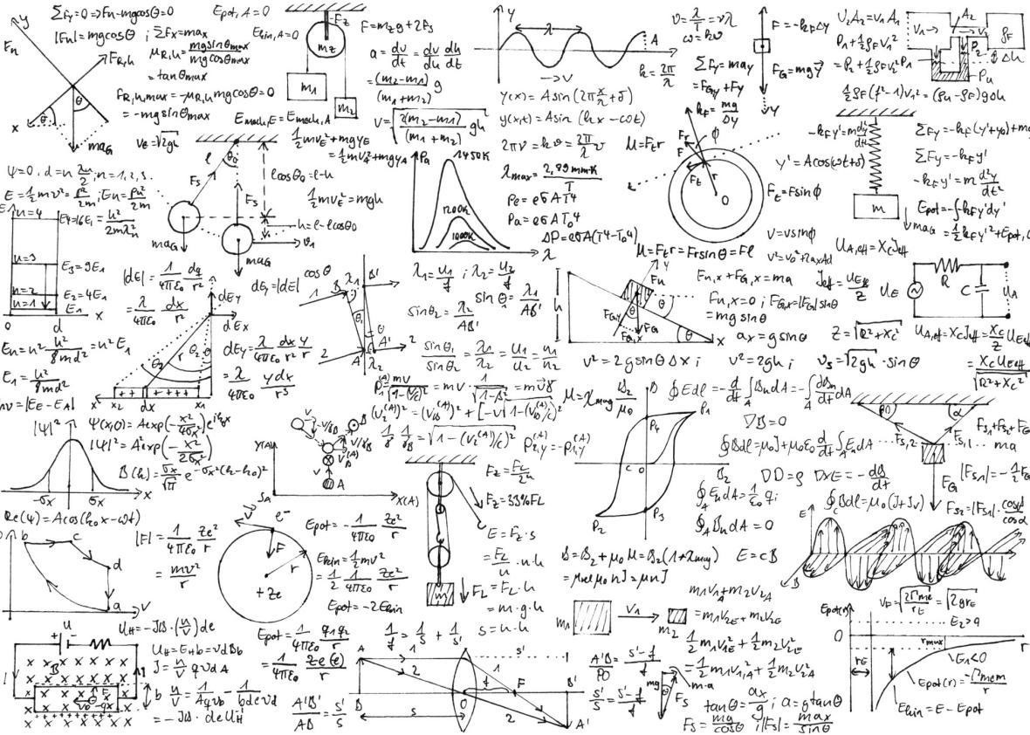

• Naive Bayes

The Algorithms

•

This week

•

Decision Trees

•

Random Forests



* XGBoost
* Other algorithms next week

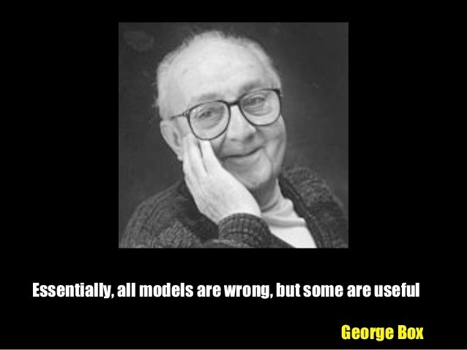

A model is a simplification or approximation of reality and hence will not reflect all of reality.

His paper was published in the Journal of the American Statistical Association, 1976 Book *Empirical Model-Building and Response Surfaces*, 1987

The Algorithms



Naive Bayes

Decision Trees

Random Forests

XGBoost

# Naïve Baye

* Naive Bayes is a probabilistic classifier in Machine Learning which is built on the principle of Bayes theorem.
* Naive Bayes classifier assumes that one particular feature in a class is unrelated to any other feature and that is why it is known as naïve
* It is based on probability models that incorporate strong independence assumptions.
* 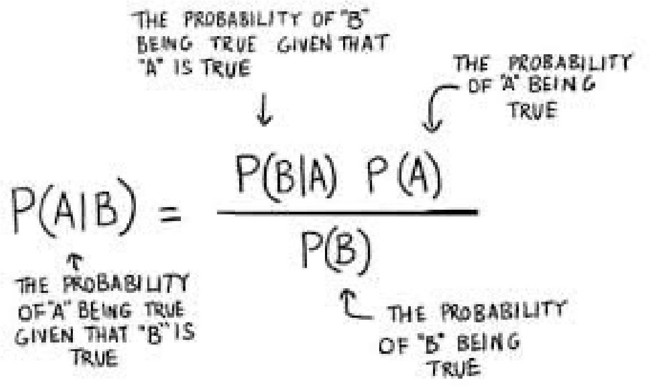The independence assumptions often have little impact on reality. Therefore they are considered as naive.
* Sounds Complicated!
* 1786!

# Naïve Baye

* Naive Bayes classifier calculates the probability of an event in the following steps:
* Step 1: Calculate the prior probability for given class labels
* Step 2: Find Likelihood probability with each attribute for each class
* Step 3: Put these values in Bayes Formula and calculate posterior probability.
* Step 4: See which class has a higher probability, given the input belongs to the higher probability class.
* Let’s look at an example

# Play-tennis example: estimating P(xi|C)

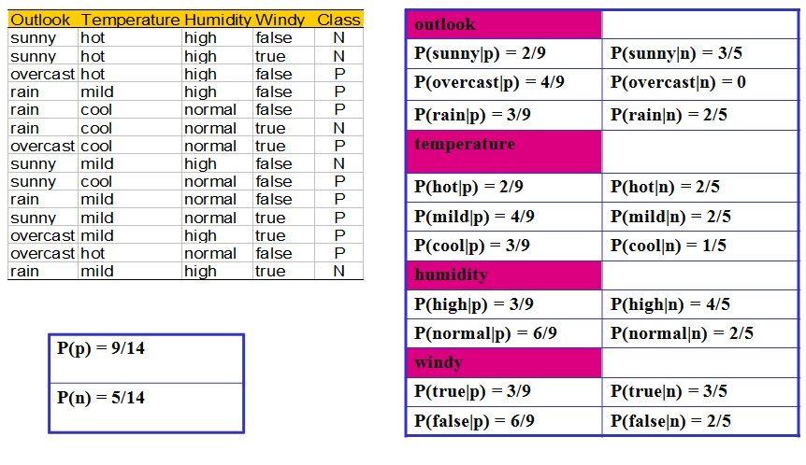

# Play-tennis example: estimating P(xi|C)



Play

-

tennis example: classifying X

§

An unseen sample X = <rain, hot, high, false>

§

P(

X|

**p**

)

·P

(

**p**

)

=

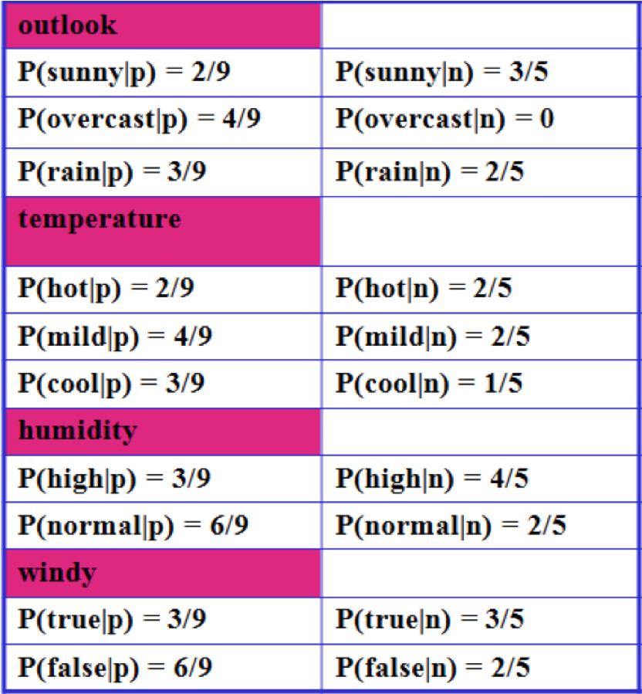

P(rain|**p**)·P(hot|**p**)·P(high|**p**)·P(false|p)·P(**p**) = 3/9·2/9·3/9·6/9·9/14 = 0.010582

* P(X|**n**)·P(**n**) =

P(rain|**n**)·P(hot|**n**)·P(high|**n**)·P(false|**n**)·P(**n**) = 2/5·2/5·4/5·2/5·5/14 = 0.018286

* Sample X is classified in class n (don’t play)

26

# Naïve Baye

* There’s a lot of Maths/Calculations
* They are all very simple calculations
* Counting
* Multiplication
* Computers are very good at doing simple Maths/Calculations -> Very fast
* You will never have to do these calculations
* It’s a tool for you to use
* Quick results
* Although may not be the most accurate
* Can be a good starting point -> benchmark other algorithms performance

The Algorithms



Naive Bayes

Decision Trees

Random Forests

XGBoost

# Decision Tree

* Does it work for just this one time or can be be used over time with different data?
* Does it work in different situations ?
* is a simplification or approximation of reality ? (George Box)

|  |  |  |
| --- | --- | --- |
|  | |  | | --- | | Decision Trees are :   * Simple * Easy to understand * Easy to explain * Everyone can follow a DT * IF-THEN statements * Easy to code * Easy to integrate into … | |

# Classification Process (1): Model Construction

Training

Data

**NAME**

**RANK**

**YEARS**

**TENURED**

Mike

Assistant Prof

3

no

Mary

Assistant Prof

7

yes

Bill

Professor

2

yes

Jim

Associate Prof

7

yes

Dave

Assistant Prof

6

no

Anne

Associate Prof

3

no

Classification

Algorithms

IF rank = ‘professor’

OR years > 6

THEN tenured = ‘yes’

Classifier

)

(

Model

**Example of a Decision Tree rule**

# Classification Process (1): Model Apply

Training

Data

**NAME**

**RANK**

**YEARS**

**TENURED**

Mike

Assistant Prof

3

no

Mary

Assistant Prof

7

yes

Bill

Professor

2

yes

Jim

Associate Prof

7

yes

Dave

Assistant Prof

6

no

Anne

Associate Prof

3

no

Classification

Algorithms

Classifier

)

Model

(

Unseen Data

(

Jeff, Professor,

4)

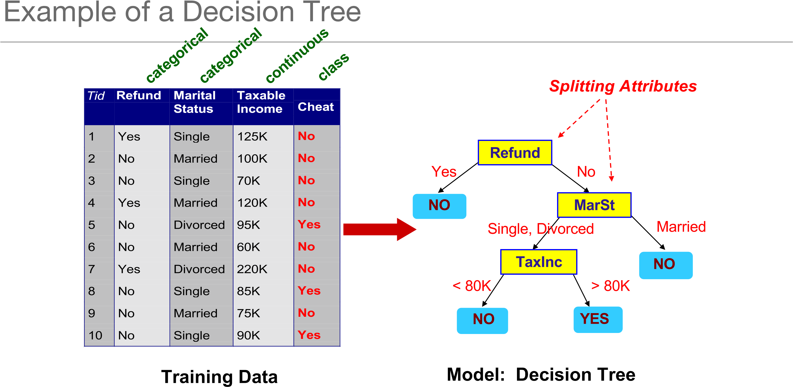

**What attribute do we start with ?** This is called Information Gain

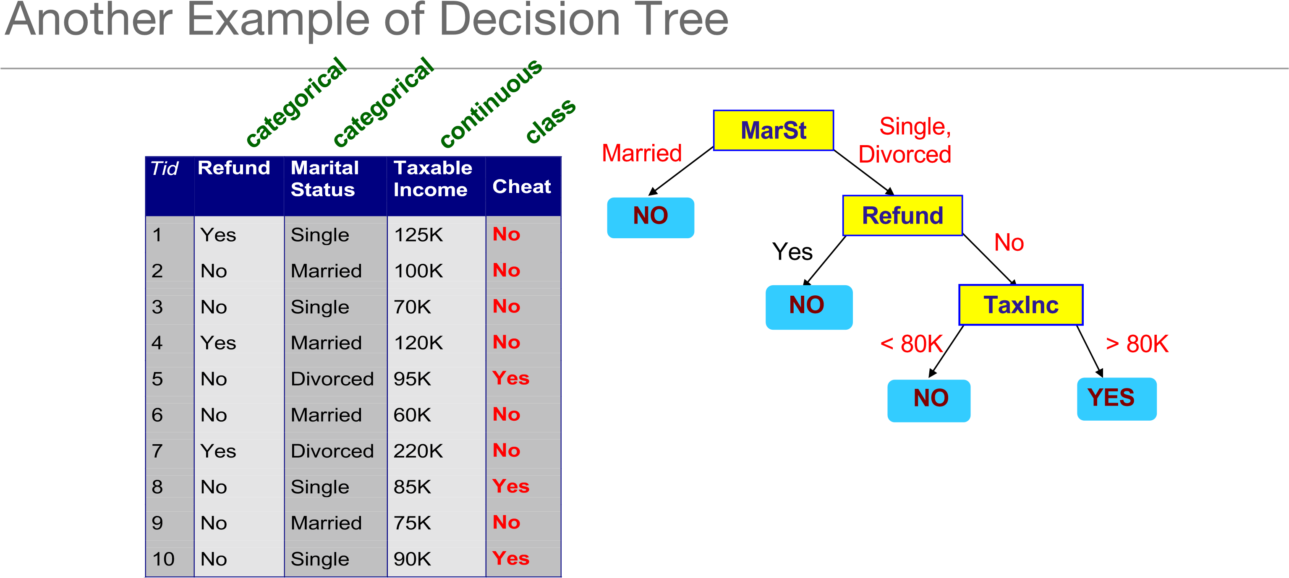

There could be more than one tree that fits the same data!

33

# Algorithm for Decision Tree Induction

* Basic algorithm (a greedy algorithm)
* Tree is constructed in a top-down recursive divide-and-conquer manner
* At start, all the training examples are at the root
* Attributes are categorical (if continuous-valued, they are discretized in advance)
* Examples are partitioned recursively based on selected attributes
* Test attributes are selected on the basis of a heuristic or statistical measure (e.g., information gain)
* Conditions for stopping partitioning
* All samples for a given node belong to the same class
* There are no remaining attributes for further partitioning – majority voting is employed for classifying the leaf
* There are no samples left

34

How to split nodes/attributes

•

Information Gain

•

Measures the level of impurity in a group

of examples

•

We want to determine which attribute in a

given set of training feature vectors is

most useful for discriminating between the

classes to be learned.

•

Information gain tells us how important a

given attribute of the feature vectors is.

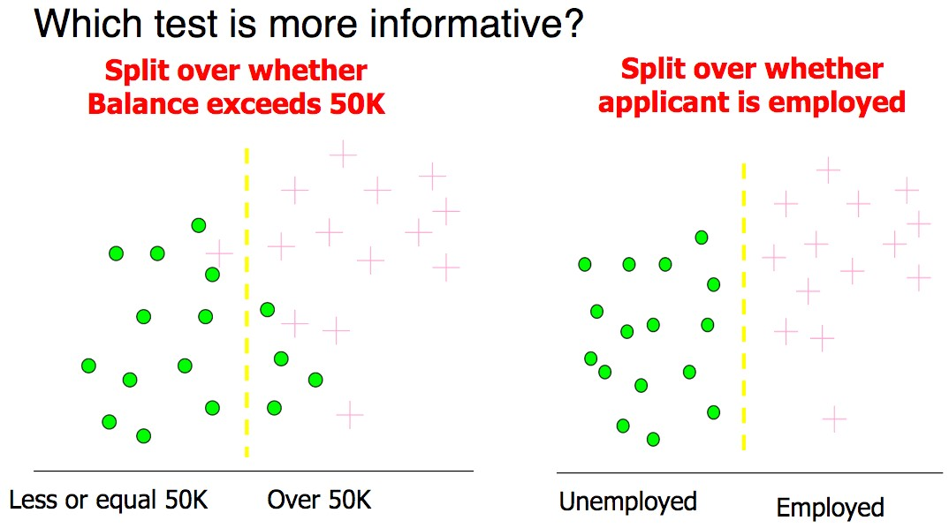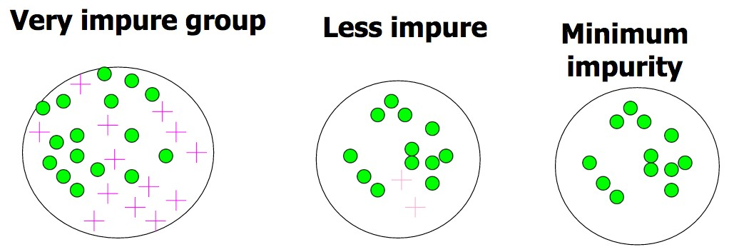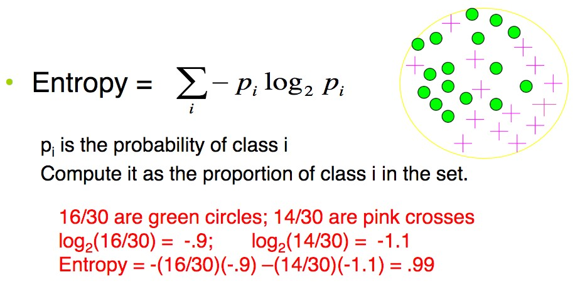

# Extracting Classification Rules from Trees

* Represent the knowledge in the form of IF-THEN rules
* One rule is created for each path from the root to a leaf
* Each attribute-value pair along a path forms a conjunction
* The leaf node holds the class prediction
* Rules are easier for humans to understand
* Example

IF *age* = “<=30” AND *student* = “*no*” THEN *buys_computer* = “*no*”

IF *age* = “<=30” AND *student* = “*yes*” THEN *buys_computer* = “*yes*”

IF *age* = “31…40” THEN *buys_computer* = “*yes*”

IF *age* = “>40” AND *credit_rating* = “*excellent*” THEN *buys_computer* = “*yes*”

IF *age* = “>40” AND *credit_rating* = “*fair*” THEN *buys_computer* = “*no*”

37

# Decision Tree Plot

•

Depends on size of Decision Tree

•

Small Decision Trees are can be plotted

•

Large Tree becomes difficult to understand

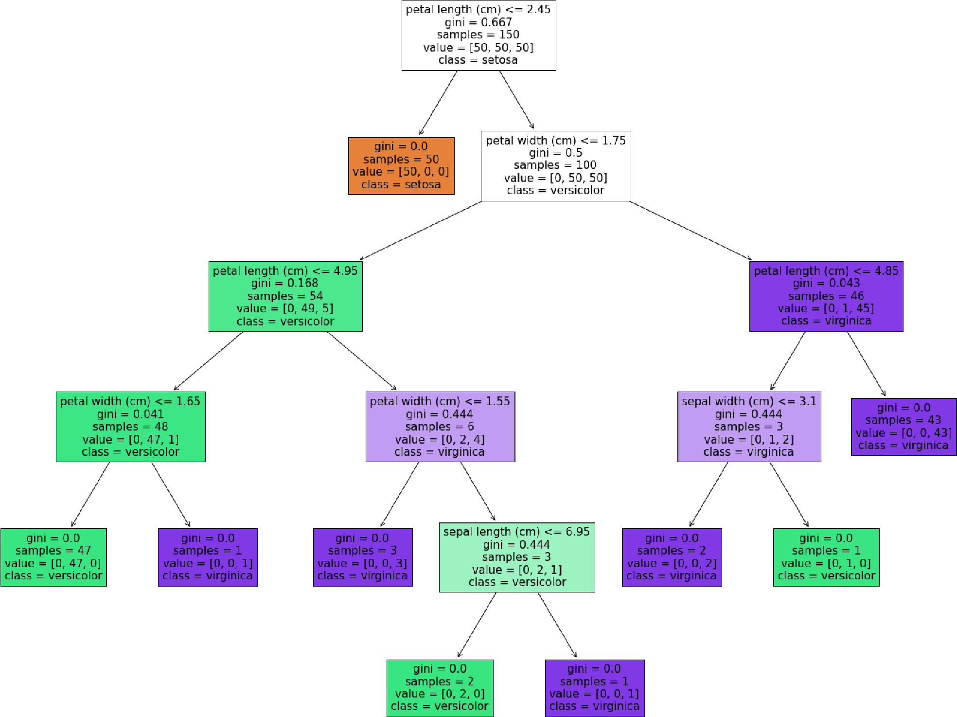

# Decision Trees

* Form the basis for other algorithms
* RandomForest
* XGBoost
* Let’s have a look at these

The Algorithms



Naive Bayes

Decision Trees

Random Forests

XGBoost

Random Forests

## § **Random forests**

* are an ensemble learning method for classification, regression and other tasks, that operate by constructing a multitude of decision trees at training time and outputting the class that is the mode of the classes (classification) or mean prediction (regression) of the individual trees.
* Wisdom of Crowds



# Random Forests

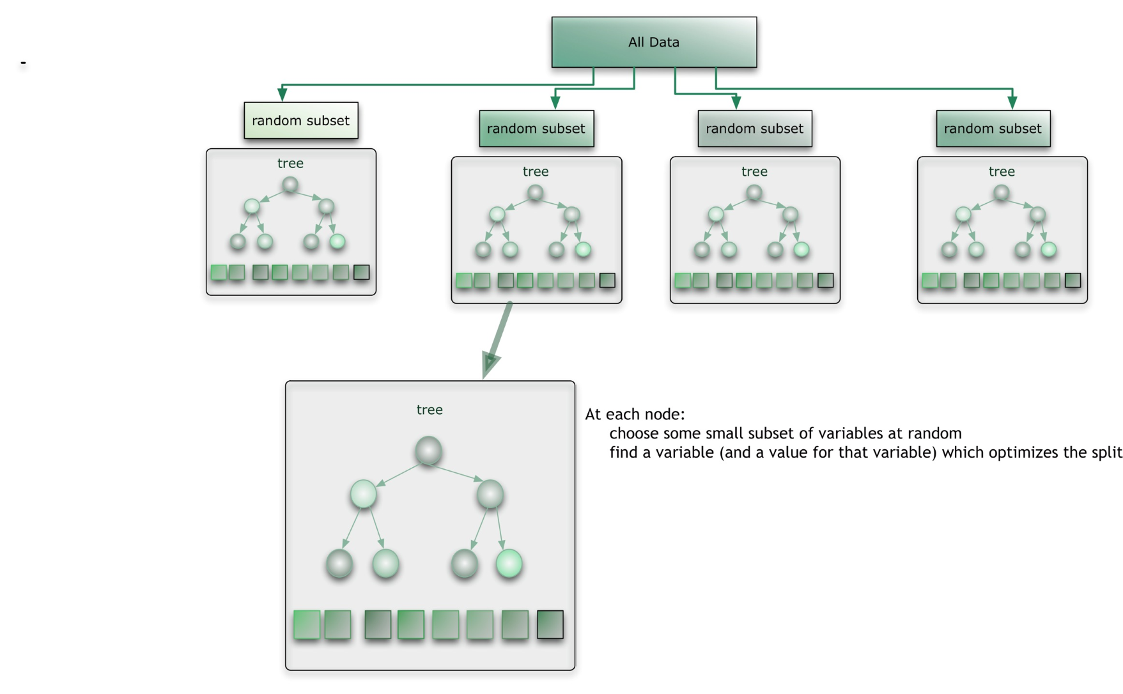• The Random Forest algorithm has three main features:

* It uses a method called bagging, to create different sub-sets of the original training data.
* It will randomly section different subsets of the features/attributes and build the decision tree based on this subset
* By creating many different decision trees, based on different subsets of the training data and different subsets of the features, will increase the probability of capturing all possible ways of modeling the data.

Random Forests

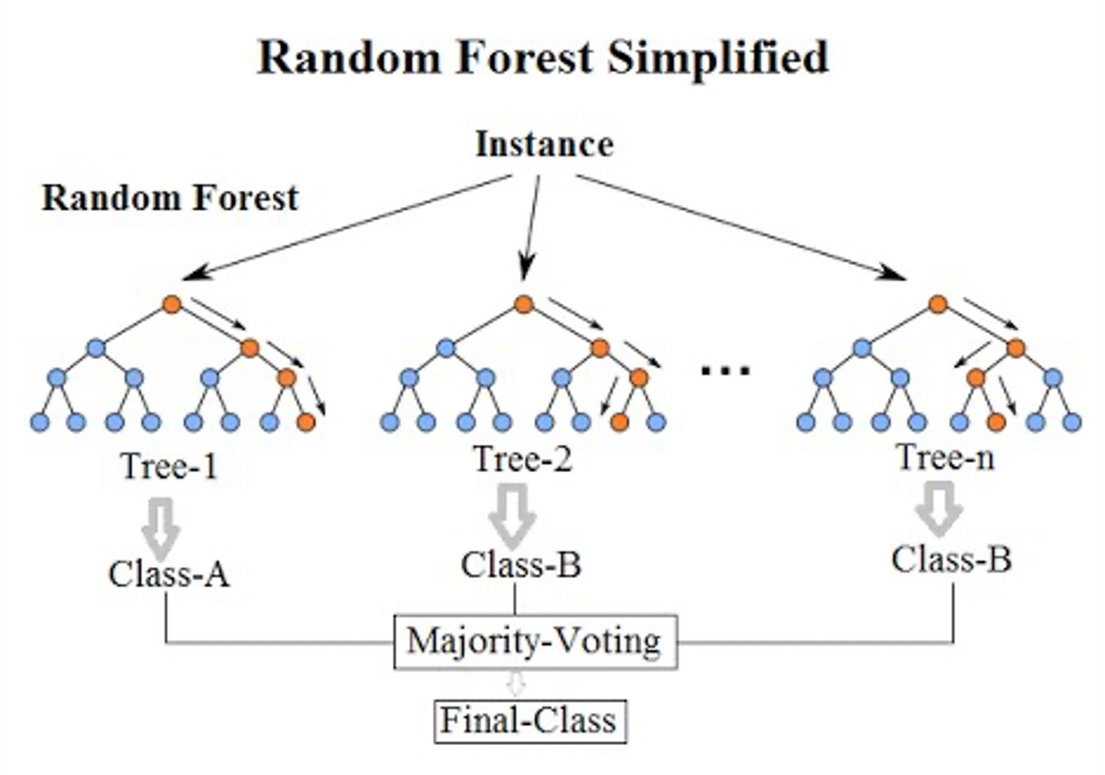

The Algorithms



Naive Bayes

Decision Trees

Random Forests

XGBoost

[Tianqi Chen and Carlos Guestrin original paper from 2016 – University of Washingto](https://arxiv.org/pdf/1603.02754.pdf)n

XGBoost: A Scalable Tree Boosting System

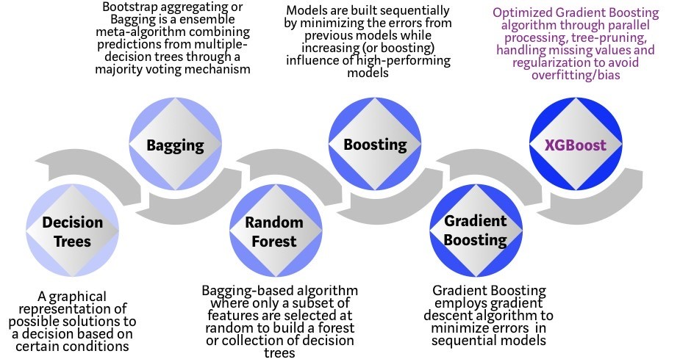Can be used for

* + Classification
  + Regression
  + Ranking problems
  + Open Source Framework
  + Kaggle Competitions
  + Builds upon previous
  + 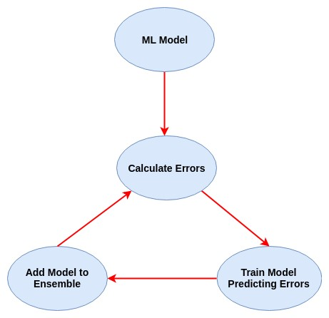Regular machine learning models, like a decision tree, simply train a single model on the dataset and use that for prediction.
  + Building an ensemble, all the models are trained and applied to our data separately.
  + **Boosting,** takes a more *iterative* approach. It’s still technically an ensemble technique with many models are combined to perform the final prediction.
  + Instead of training all the models in isolation of one another, boosting trains models in succession, with each new model being trained to correct the errors made by the previous ones.
  + Models are added sequentially until no further improvements can be made.
  + 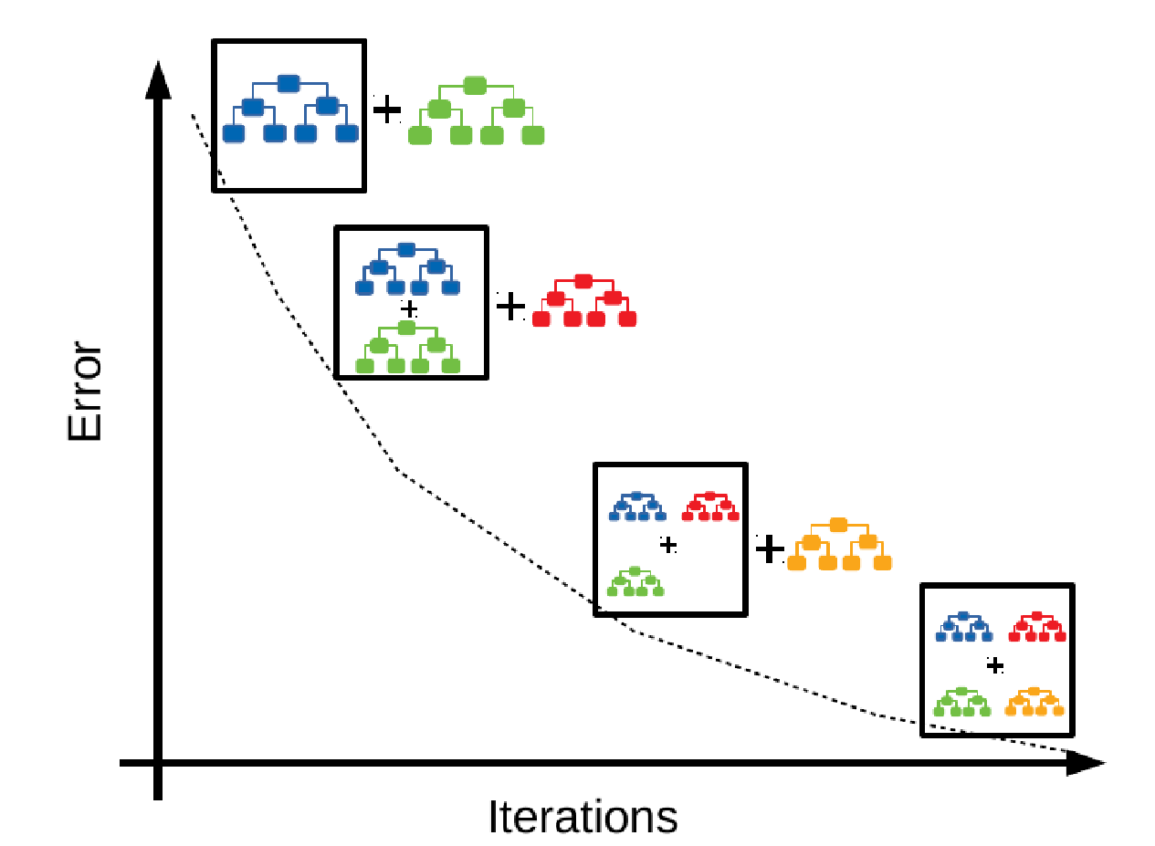Advantage is the new models being added are focused on correcting the mistakes which were caused by other models.
  + Each subsequent model is trained on a smaller portion of data
  + Quicker to create each subsequent model
  + In regular ensemble methods models are trained in isolation, all the models might end up making the same mistakes!
  + **Gradient Boosting** specifically is an approach where new models are trained to predict the errors of prior models Optimised for
* Parallel processing
* Tree Pruning – Depth first approach
* 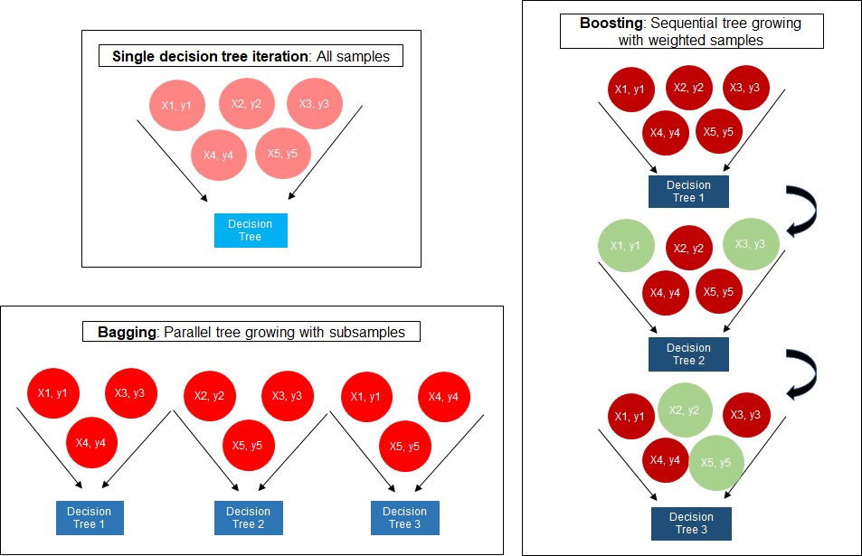Memory, Cache and Hardware optimised
* Fewer resources

# Test & Evaluate

Test & Evaluation



Why do we evaluate?

* Why do we evaluate the models created?
* Remember, we will create many models -> We need to find the one that works best
* The one that works best, on our data (as it is now), for our problem, at this point in time
* If we were to rerun all the code again with minor changes, we could get a different outcome
* What will work best for us
* To determine which model is the most suitable for a task
* To communicate to (business) users on what should be used

## How do we evaluate

* It isn’t complicated – But many make it complicated
* It’s very simple really!
* In reality it is just Counting
* How many you correctly predicted
* How many you incorrectly predicted
* Remember, a model will/can never be 100% correct
* It is an approximation
* Keep It Simple!

## Classifier Accuracy

* The **accuracy** of a classifier on a given test set is the percentage of test set tuples that are correctly classified by the classifier
* Often also referred to as **recognition rate**
* **Error rate** (or **misclassification rate**) is the opposite of accuracy

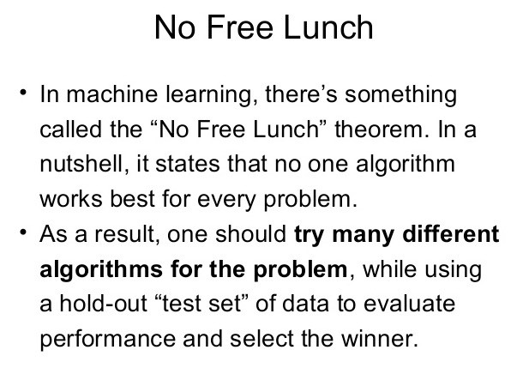

53

## False Positives Vs False Negatives

* While it is useful to generate the simple accuracy of a classifier, sometimes we need more
* When is the classifier wrong?
* False positives vs false negatives
* Related to type I and type II errors in statistics
* Often there is a different cost associated with false positives and false negatives § Think about diagnosing diseases

54

## Test Dataset

• We run the model against the “unseen” dataset -> Test Dataset

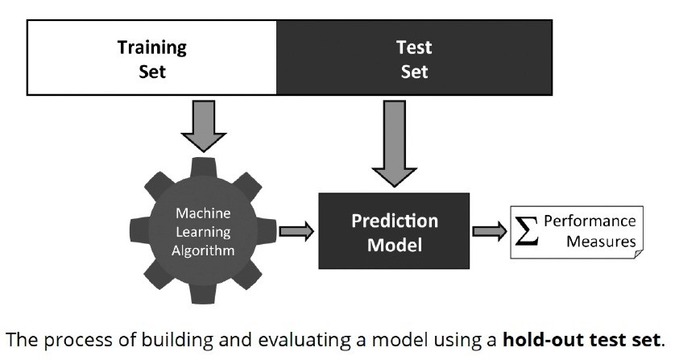

## Confusion Matrix

* Confusion Matrix used to illustrate how a classifier is performing in terms of false positives and false negatives
* Gives us more information than a single accuracy figure
* Allows us to think about the cost of mistakes
* Can be extended to any number of classes
* 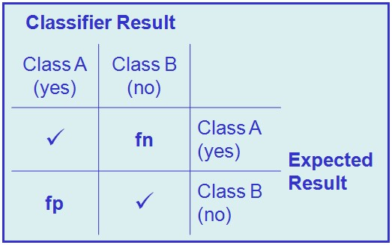Binary Classification
* Multi-Class Classification

56

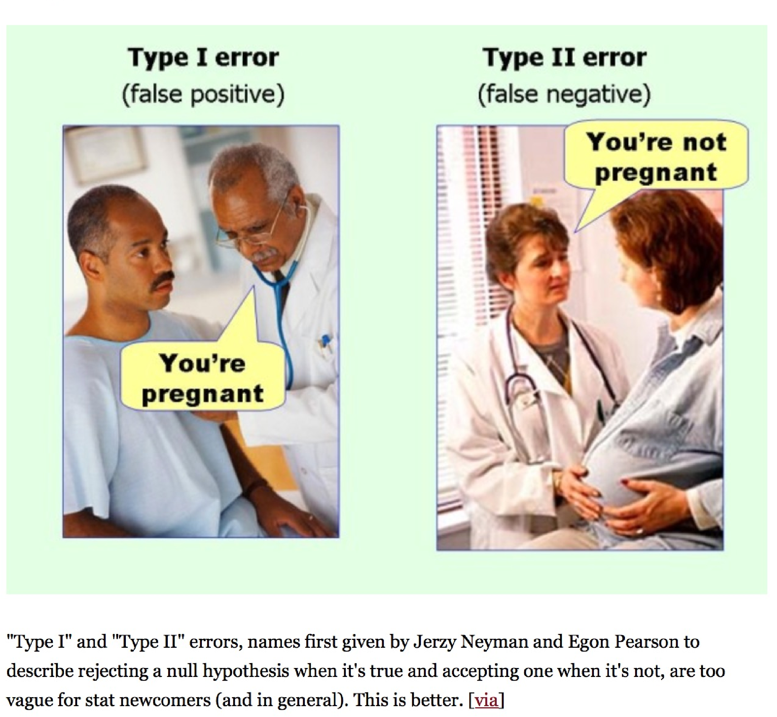Type I &

Type II

Errors

Type I &

Type II

Errors

Lots of different versions of this. All are saying the same thing

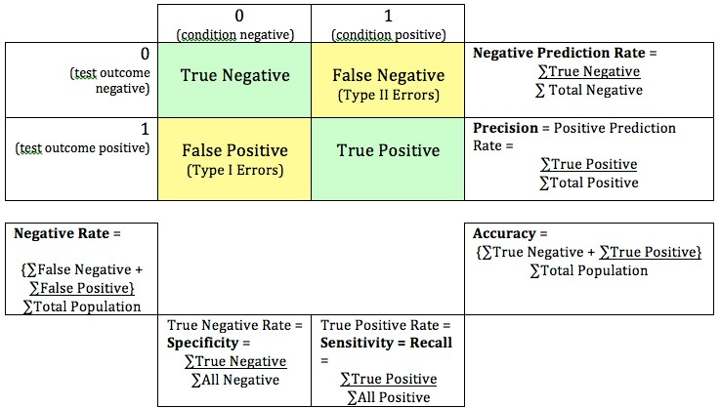



The attachment is

not

a virus

& correctly predicted

The attachment

is a

virus

& correctly predicted

The attachment is

not

a virus

but is predicted

as

a virus

The attachment

is a

virus

But I’ve predicted it as

not

being a virus

The customer commits fraud



The customer

does not

commit fraud

The customer commits fraud

The customer

does not

commit fraud

but is predicted

as

committing fraud

But is predicted as

not

committing fraud

The patient does have the condition



The patient does

not

have the condition

The patient does

have

the condition

The patient does

not

have the condition

But we have predicted

they have

condition

But we have predicted they

don’t

## - Example

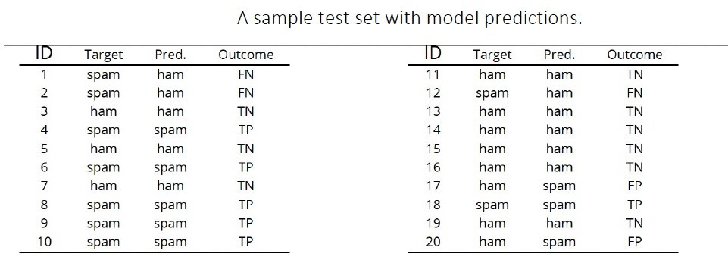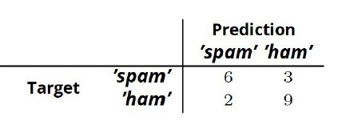

## - Example

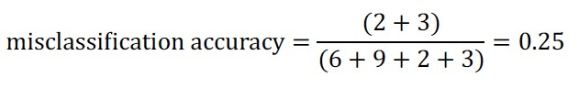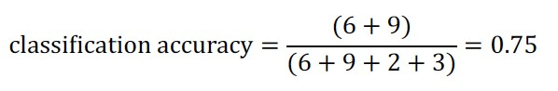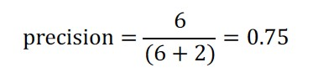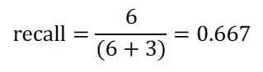

* Not every outcome (or classification) has the same value
* A positive outcome could be worth money €

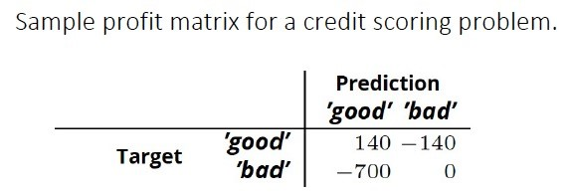

* A negative outcome could be work lots of money lost -€€€
* We can apply monetary values to the outcomes
* Not every outcome (or classification) has the same value
* A positive outcome could be worth money €
* A negative outcome could be work lots of money lost -€€€
* We can apply monetary values to the outcomes



How much

€

can we make by

getting this correct

We will do nothing with these.

So no cost/

€

We should have approved these.

But we didn’t.

Missed opportunity cost

* Not every outcome (or classification) has the same value
* A positive outcome could be worth money €
* A negative outcome could be work lots of money lost -€€€
* We can apply monetary values to the outcomes



How much

€

can we make by

getting this correct

We will do nothing with these.

So no cost/

€

We should have approved these.

But we didn’t.

Missed opportunity cost

* Not every outcome (or classification) has the same value
* A positive outcome could be worth money €
* A negative outcome could be work lots of money lost -€€€
* We can apply monetary values to the outcomes



How much

€

can we make by

getting this correct

We will do nothing with these.

So no cost/

€

We should have approved these.

But we didn’t.

Missed opportunity cost

* Add up the numbers from each part/box of the Confusion Matrix
* Total = € potential value for model
* Accountants like to see these numbers
* Your managers like to see these numbers
* Bosses like to see these numbers
* It quantifies/costs the potential € for each model
* The Business will understand using € (Language of Business)
* Vs using Numbers + Percentages + Unusual Terms (Language of Analysts, Machine Learning, etc )

## Hold-Out Testing Sets

* Split the available data into a *training set* and a *test set*

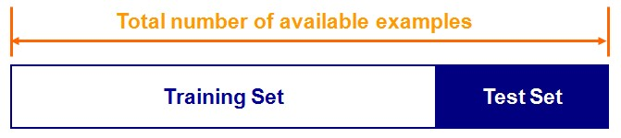

* Train the classifier in the training set and evaluate based on the test set
* A couple of drawbacks
* We may not have enough data
* We may happen upon an *unfortunate split*

## K-Fold Cross Validation

* An alternate is to divide the dataset into smaller chunks (Train & Test)
* k *folds* – where k is the number of times to divide the data
* For each of k experiments, use kth fold for testing and everything else for training
* Average the results across the k folds

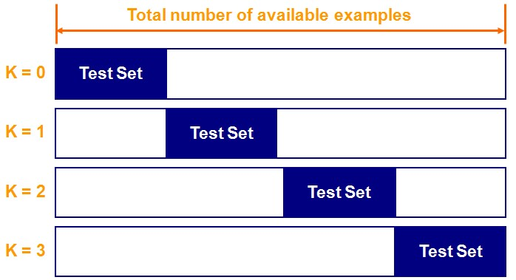

## K-Fold Cross Validation

* The accuracy of the system is calculated as the average error across the k folds
* The main advantages of k-fold cross validation are that every example is used in testing at some stage and the problem of an *unfortunate split* is avoided
* Any value can be used for k
* 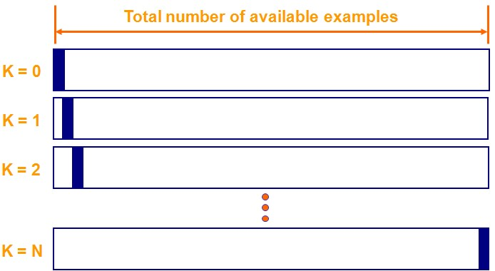10 is most common
* Depends on the data set

A lot covered

•

We have covered a lot in this class

•

What is Classification

•

Different Algorithms

•

How to Evaluate

•

Keep It Simple!

•

Lab Work

•

Examples of the Algorithms

•

Examples of Evaluation

•

A

few lines

of code

•

Next week we will

•

Look at a few more algorithms

•

Go over the Evaluate steps again



Time for an

Example

Any Questions ?

What Now/Next ?